Beyond The Page Ltd.  “Women’s Voices Together, Building Strong Communities” | 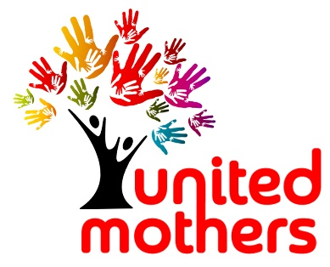
Referral Form for United Mothers Chatrooms

We are now online until at least December 2020.
The United Mothers Chatrooms provide free, women-only ESOL (English for Speakers of Other Languages) and community integration groups.
Session the new member is interested in (please select): | United Mothers Chatrooms  Online | Face-to-Face Only  We aren’t currently meeting face to face, but have a waiting list

Referral date:
Name of person being referred (first and family name):
Phone:

Email:
Country/Language(s):
When did she move to the UK?:
English level (circle): | Beginner | Basic | Medium-Fluent

Any other information
(e.g. disabilities/ known to United Mothers member/enrolled in ESOL):
P.T.O à

Please detach this slip and hand to the woman you are referring
United Mothers is a friendly, women-only group that offers free ESOL (English) on
computer.
Someone from United Mothers will contact you in 1 week.

Referrer details

Name: ………………………………………………………………………………………………………………………………………………………………..

Job: ……………………………………………………………………………………………….……………………………………………….…………………..

Contact phone: ………………………………………………………………………………………………………………………………………………….

Email address: ……………………………………………………………………………………………………………………………………………………

Return this form
By email: Laura Baker, Operations Development Manager
admin@beyondthepage.org.uk / 07594 554793
By post: Beyond The Page, Kent Innovation Centre, Millennium Way, Broadstairs CT10 2QQ

Next Steps
A member of the team will contact the referred woman to enrol her in a Chatroom or put her on the waiting list for a face-to face session. We will let you know the outcome.
Any questions? - email Laura Baker, Operations Development Manager at admin@beyondthepage.org.uk or phone her on 07594 554793

“United Mothers” is run by Beyond The Page Ltd, a Thanet-based, independent, non-profit organisation.
For more information or to see our privacy notice, see www.beyondthepage.org.uk

Need help or more information? You can call Laura Baker T: 07594 554793

We look forward to welcoming you!

